**Android Assignment 2 (of 5)**

* Create an Android applications that looks like the following:

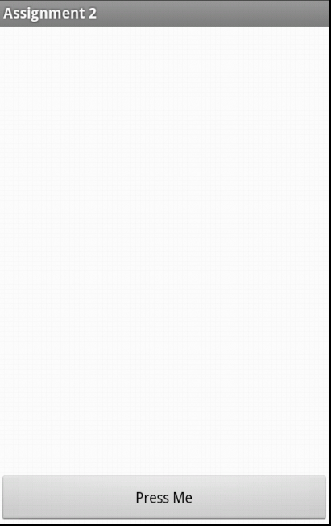

* When the button on the bottom is pressed the words “Android is great!!” is displayed in the Text window as shown:

